 NAME: Rogelio Angelo V. Duque

1. Transform the following arithmetic expressions to its equivalent computer expressions:
2. Perimeter = 2l + 2w

**l = 2, w = 2**

**Perimeter = l + w**

1. Vol = length x width x height

**Vol = length * width * height**

1. Grade = 10% Assignment + 20% Seat_work + 30 % Quizzes + 40% Exam

**Assignment = 0.10**

**Seat_work = 0.20**

**Quizzes = 0.30**

**Exam = 0.40**

**Grade = Assignment + Seat_work + Quizzes + Exam**

1. Solve the problem statements by simulating the given values of the variables below:

X = 5; Y = 10; Z = 15; A = 2; B = 4; C = 6

1. if A = Z; Z = B what is the value of B? **Answer: 4;**
2. if X = Y; X = Z what is the value of X?  **Answer: 15;**
3. if B = C; A = X; Y = Z what is the value of A? **Answer: 2;**
4. if A = B; B = C; C = X what is the value of A? **Answer: 4;**
5. if Z = Y; Y = X; Y = Z what is the value of Z? **Answer: 15;**
6. if X = B; X = C; what is the value of X? **Answer: 6;**
7. if B = A; B = C; what is the value of B and C? **Answer: 6; and 6;**

1. Solve the following problems by applying what you’ve learned in this module.
2. Income tax is computed based on net taxable income. The income tax table is as follows:

***Net Taxable Income (NTI)*** ***Tax Due***

Below 2,500 P0

At least 2,500 but below 5000 P100 + 3% of NTI

At least 5,000 but below 10,000 P175 + 5% of NTI

At least 10,000 but below 25,000 P425 + 8% of NTI

At least 25,000 but below 50,000 P1625 + 13% of NTI

At least 50,000 P4875 + 25% of NTI

Make a program that would input the gross income and tax exemption and then output the tax due. (Net taxable income equals gross minus tax exemption).

#include<iostream>

using namespace std;

int main()

{

float grossIncome,taxExemption, taxDue;

    cout << "Enter Your Gross Income: ";

    cin >> grossIncome;

    cout << "\n";

    cout << "Your Gross Income: " << grossIncome << endl;

    if(grossIncome < 2500){

        cout << "Your Tax Exemption: P0" << endl;

        cout << "Your Tax Due Is P0";

    }

    else if((grossIncome >= 2500)&&(grossIncome < 5000)){

        taxExemption = (0.03 *grossIncome) + 100;

        taxExemption = grossIncome - taxExemption;

        cout << "Your Tax Exemption: " << taxExemption << endl;

        taxDue = 0.03 * grossIncome + 100;

        cout << "Your Tax Due is P100 + 3% of NTI = " << taxDue;

    }

    else if((grossIncome >= 5000)&&(grossIncome < 10000)){

        taxExemption = (0.05 *grossIncome) + 175;

        taxExemption = grossIncome - taxExemption;

        cout << "Your Tax Exemption: " << taxExemption << endl;

        taxDue = 0.05 * grossIncome + 175;

        cout << "Your Tax Due is P175 + 5% of NTI = " << taxDue;

    }

    else if((grossIncome >= 10000)&&(grossIncome < 25000)){

        taxExemption = (0.08 *grossIncome) + 425;

        taxExemption = grossIncome - taxExemption;

        cout << "Your Tax Exemption: " << taxExemption << endl;

        taxDue = 0.08 * grossIncome + 425;

        cout << "Your Tax Due is P425 + 8% of NTI = " << taxDue;

    }

    else if((grossIncome >= 25000)&&(grossIncome < 50000)){

        taxExemption = (0.13 *grossIncome) + 1625;

        taxExemption = grossIncome - taxExemption;

        cout << "Your Tax Exemption: " << taxExemption << endl;

        taxDue = 0.13 * grossIncome + 1625;

        cout << "Your Tax Due is P1625 + 13% of NTI = " << taxDue;

    }

    else if(grossIncome >= 50000){

        taxExemption = (0.25 *grossIncome) + 4875;

        taxExemption = grossIncome - taxExemption;

        cout << "Your Tax Exemption: " << taxExemption << endl;

        taxDue = 0.25 * grossIncome + 4875;

        cout << "Your Tax Due is P4875 + 25% of NTI = " << taxDue;

    }

  return 0;

}

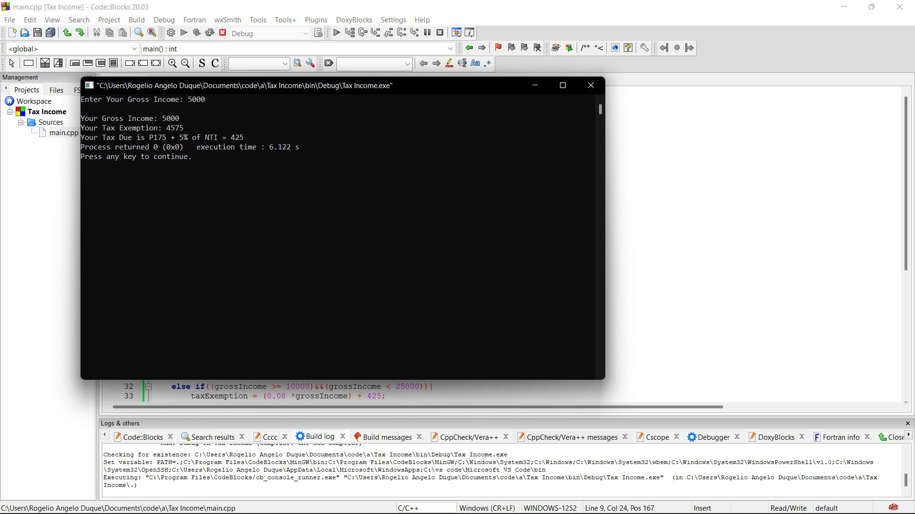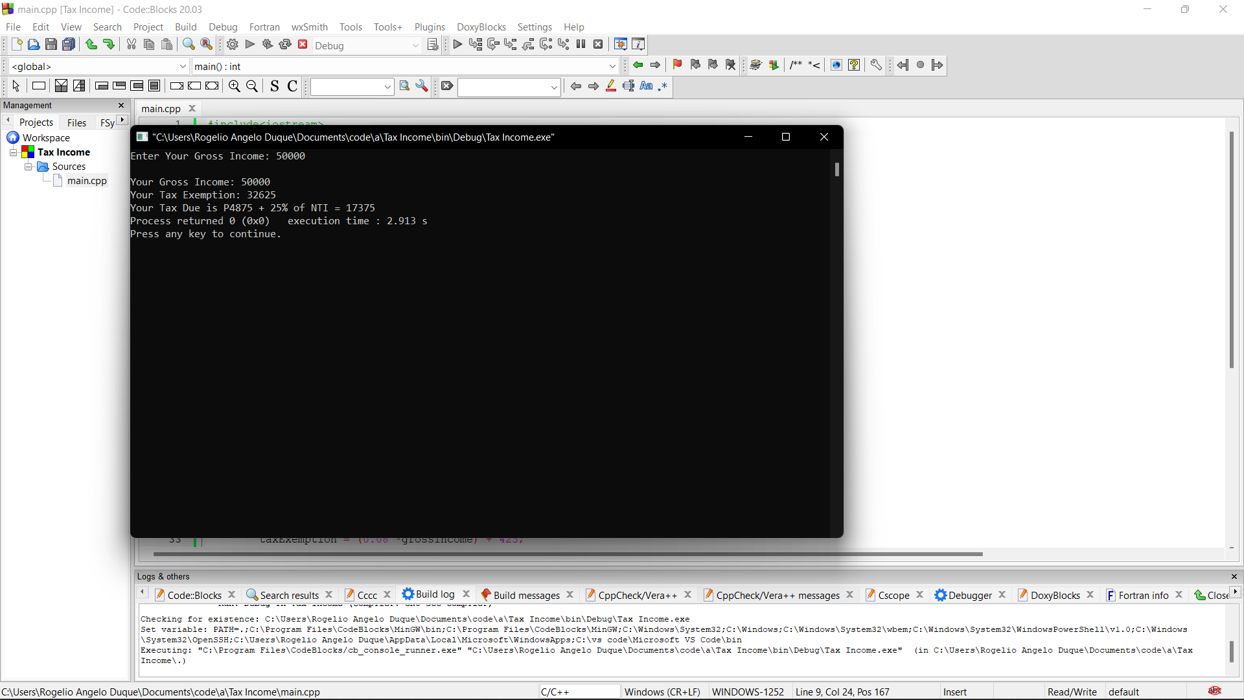

1. Write a program that reads in a time of day in 24-hr notation and output it in 12-hr notation. For example, if the input is 1345,the output should be 1:45 PM. If input is 920, output should be 9:20 AM. Consider 1200 midnight as 12:00 AM and 2400 noon as 12:00 PM.

#include <iostream>

using namespace std;

int main()

{

//inputs

int hrs, mins, time;

    cout<<"Enter a 24-hour time you want to convert to 12-Hour Notation: ";

    cin>> time;

//for Am

    if(time <1300){

    hrs=time/100;

    mins=time%100;

    if ((mins >0)&&(mins <=9)){

        cout<<hrs<<":0"<<mins<<" AM";

    }

    else if((mins >=10)&&(mins <60)){

        cout<<hrs<<":"<<mins<<" AM";

    }

    else if((time >=0)&&(mins <=1300)){

        cout<<hrs<<":0"<<mins<<" AM";

    }

    }

//For Pm

    if((time >= 1300)&&(time <=2400)){

    hrs=time/100-12;

    mins=time%100;

    if ((mins >0)&&(mins <=9)){

        cout<<hrs<<":0"<<mins<<" Pm";

    }

    else if((mins >=10)&&(mins <60)){

        cout<<hrs<<":"<<mins<<" PM";

    }

    else if((time >=1300)&&(mins <=2400)){

        cout<<hrs<<":0"<<mins<<" PM";

    }

    }

    return 0;

}

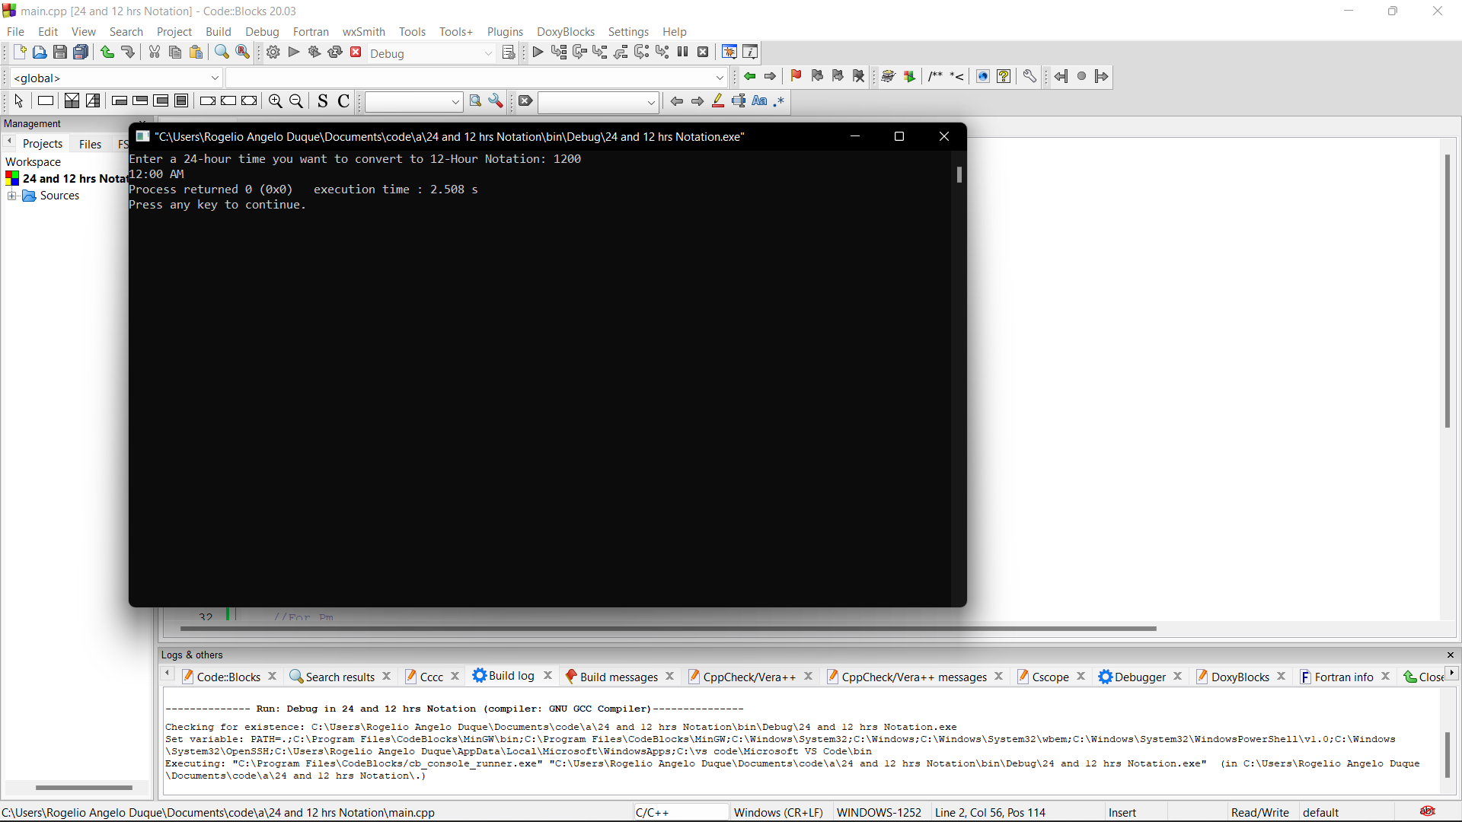

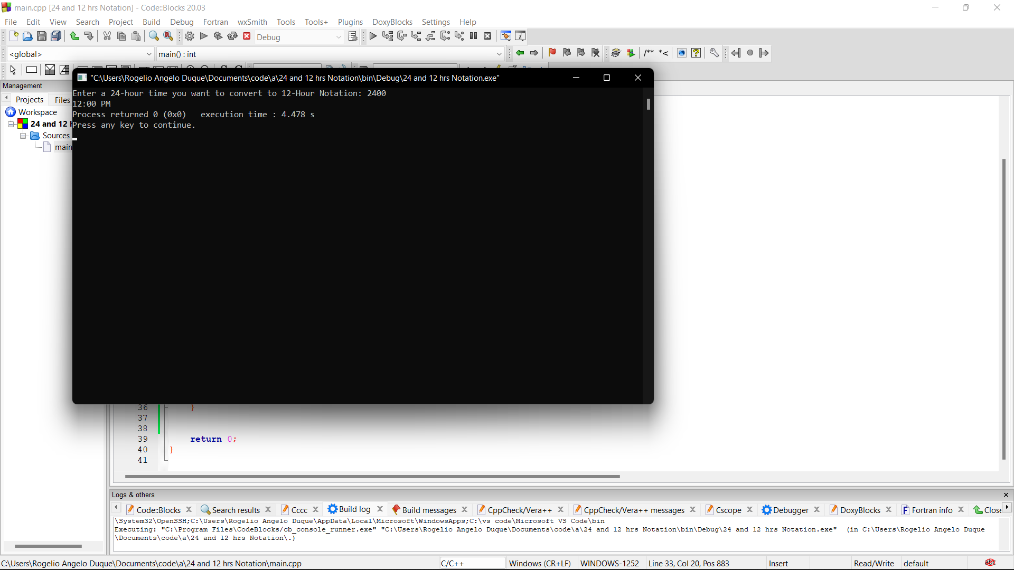

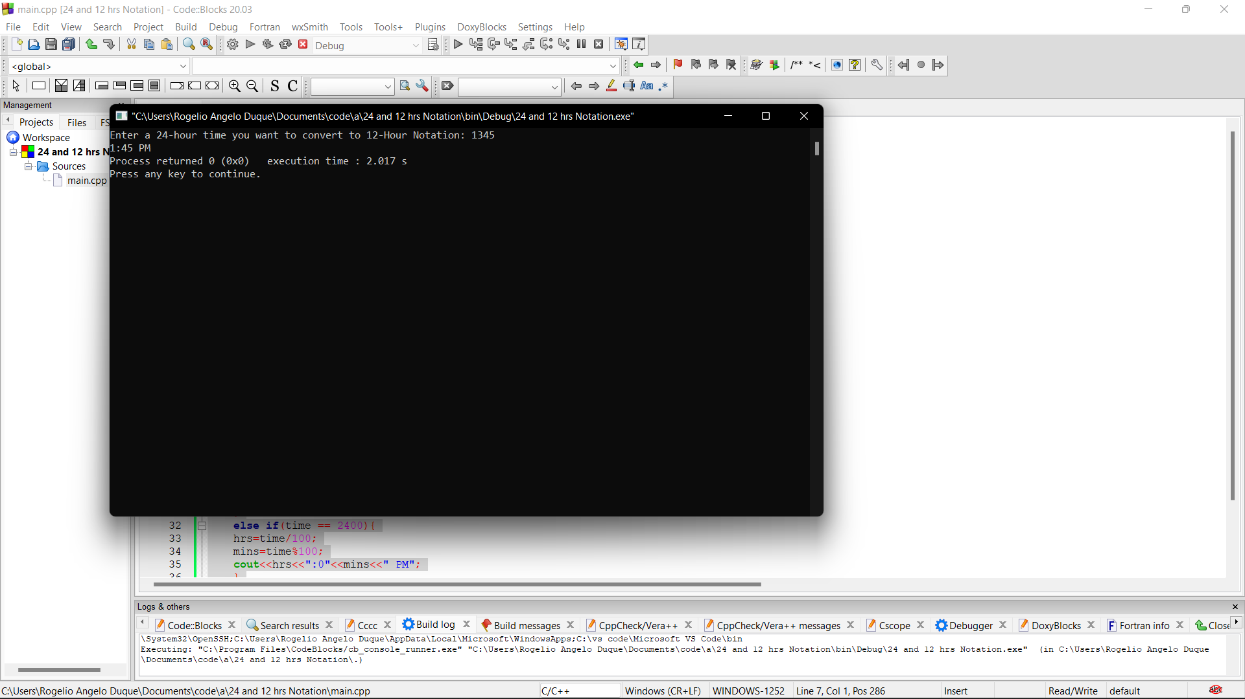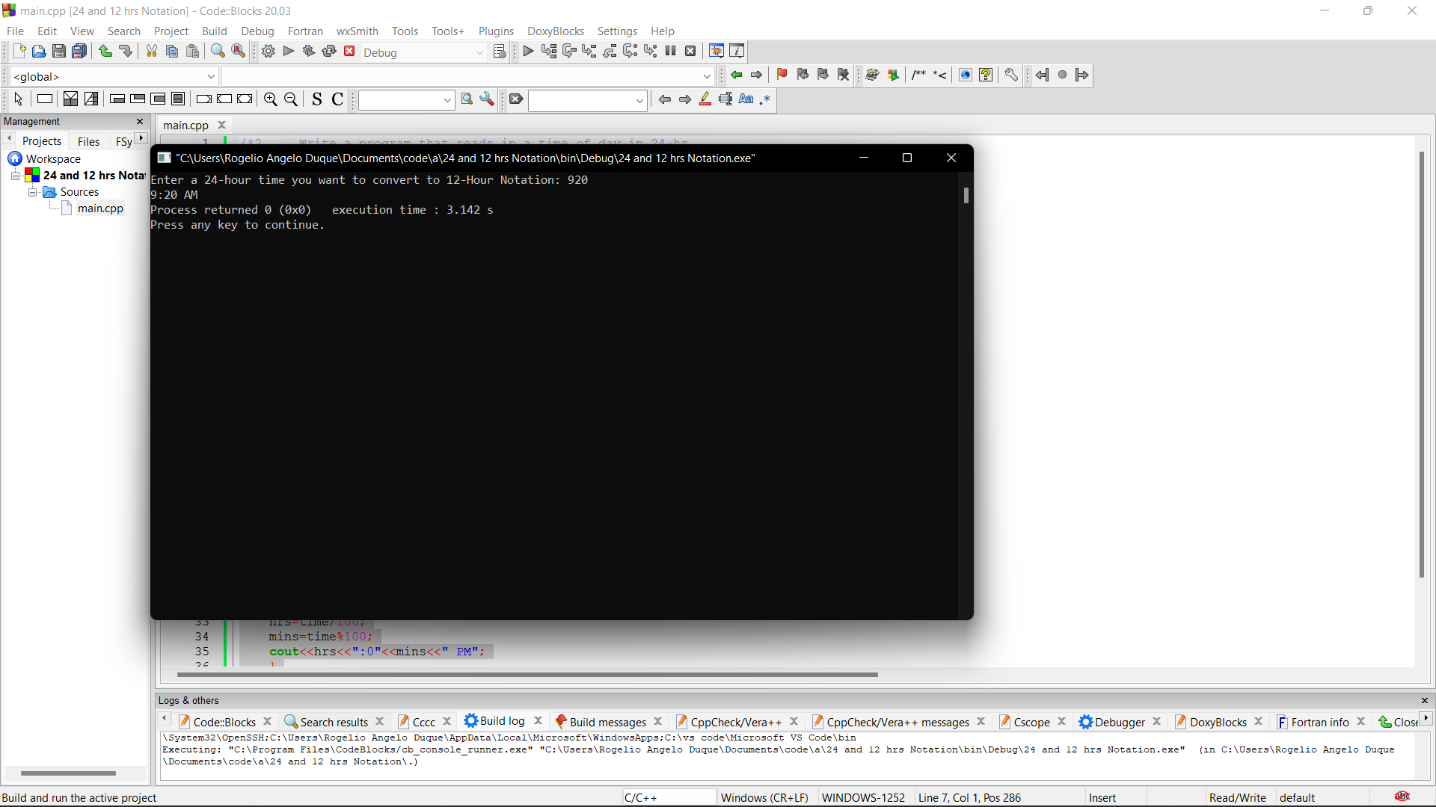

1. It is known that January 2006 starts on Sunday. Make a program that would input a numeric day (between1 and 31) and output the day of the week the day falls. For example, if 4 is entered for the day, the program must display "WEDNESDAY", if 8 was entered, "SUNDAY" must be displayed and so on.

 #include <iostream>

using namespace std;

int main()

{

    int numericDay;

    cout<<"Enter numeric day: ";

    cin>>numericDay;

    if (((((numericDay ==2)||(numericDay ==9)||(numericDay ==16)||(numericDay ==23)||(numericDay ==30))))){

        cout<<"MONDAY";

    }

    else if (((((numericDay ==3)||(numericDay ==10)||(numericDay ==17)||(numericDay ==24)||(numericDay ==31))))){

        cout<<"TUESDAY";

    }

    else if ((((numericDay ==4)||(numericDay ==11)||(numericDay ==18)||(numericDay ==25)))){

        cout<<"WEDNESDAY";

    }

    else if ((((numericDay ==5)||(numericDay ==12)||(numericDay ==19)||(numericDay ==26)))){

        cout<<"THURSDAY";

    }

    else if ((((numericDay ==6)||(numericDay ==13)||(numericDay ==20)||(numericDay ==27)))){

        cout<<"FRIDAY";

    }

    else if ((((numericDay ==7)||(numericDay ==14)||(numericDay ==21)||(numericDay ==28)))){

        cout<<"SATURDAY";

    }

    else if (((((numericDay ==1)||(numericDay ==8)||(numericDay ==15)||(numericDay ==22)||(numericDay ==29))))){

        cout<<"SUNDAY";

    }

    else{

        cout<<"You enter a invalid numeric day";

    }

    return 0;

}

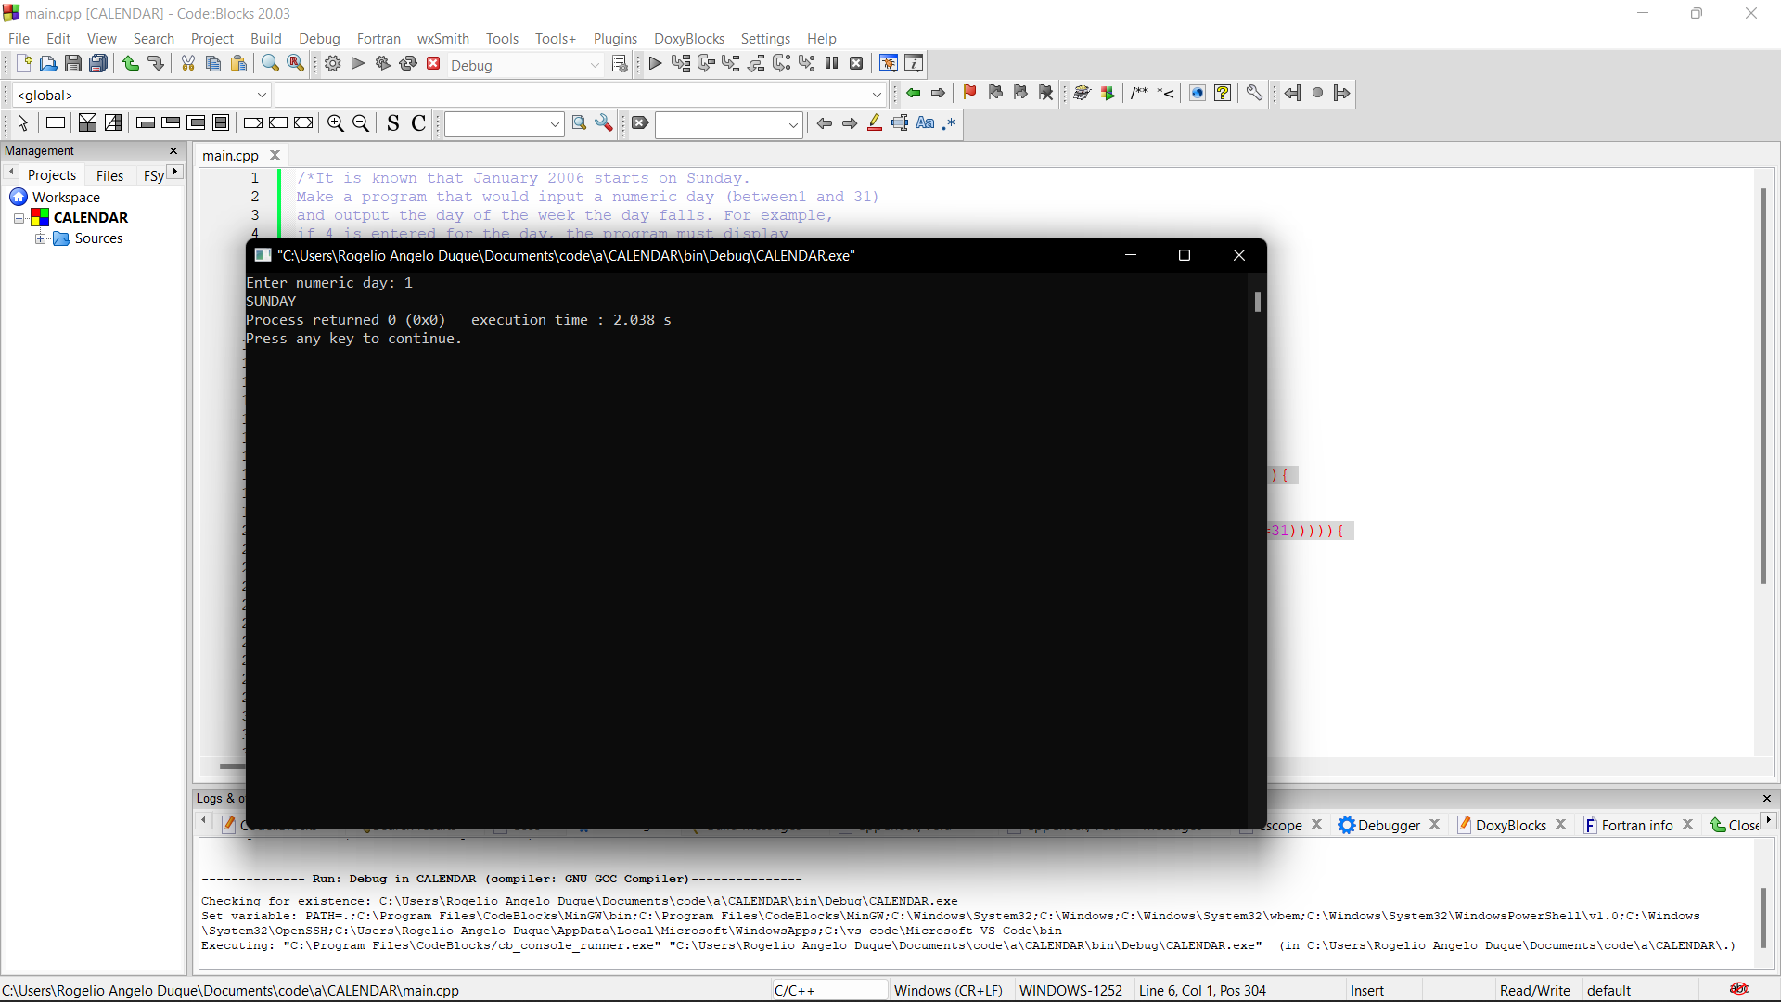

1. The cost of a brand new car is P420,000 for GL model and P398,000 for XL model. If a car phone will be installed, an additional P40,000 will be added to the cost. Moreover, a 15% discount on the total cost will be given if the buyer pays in full (not installment).

Write a program that would input the car model bought whether with car phone (use code "W" for car with car phone and "O" for without car phone) and whether it will be paid in full (use code "F" for full payment and "I" for installment). Program must then output the net cost of the car.

#include <iostream>

using namespace std;

int main()

{

//DATA

    string carModel;

    char phone, payment;

    int GL, XL, W, O, F, I, netCost;

    float discount;

GL = 420000;

XL = 398000;

W = 40000;

discount = 0.15;

//INPUTS

    cout << "Car Model (GL, XL): ";

    cin>> carModel;

    cout << "(W)With Phone or (O)Without Phone: ";

    cin>> phone;

    cout << "(F) Fullpayment or (I) Installment: ";

    cin>> payment;

cout << "\n";

//GL. STATEMENTS

    if(carModel == "GL" && phone == 'W'&& payment== 'F'){

        discount = discount * (GL + W);

        netCost = (GL+W)- discount;

    cout<<"Total Discount: P"<<discount<<"\nTotal Cost: P"<<netCost;

    }

    else if(carModel == "GL" && phone == 'O'&& payment== 'I'){

        netCost = GL;

    cout<<"Total Cost: P"<<netCost;

    }

    else if(carModel == "GL" && phone == 'W'&& payment== 'I'){

        netCost = GL + W;

    cout<<"Total Cost: P"<<netCost;

    }

    else if(carModel == "GL" && phone == 'O'&& payment== 'F'){

        discount = discount * GL;

        netCost = GL - discount;

    cout<<"Total Discount: P"<<discount<<"\nTotal Cost: P"<<netCost ;

    }

 //xl

    else if(carModel == "XL" && phone == 'W'&& payment== 'F'){

        discount = discount * (XL + W);

        netCost = (XL+W)- discount;

    cout<<"Total Discount: P"<<discount<<"\nTotal Cost: P"<<netCost;

    }

    else if(carModel == "XL" && phone == 'O'&& payment== 'I'){

        netCost = XL;

    cout<<"Total Cost: P"<<netCost;

    }

    else if(carModel == "XL" && phone == 'W'&& payment== 'I'){

        netCost = XL + W;

    cout<<"Total Cost: P"<<netCost;

    }

    else if(carModel == "XL" && phone == 'O'&& payment== 'F'){

        discount = discount * XL;

        netCost = XL - discount;

    cout<<"Total Discount: P"<<discount<<"\nTotal Cost: P"<<netCost ;

    }

    else {

        cout<<"Invalid";

    }

cout << "\n";

    return 0;

}

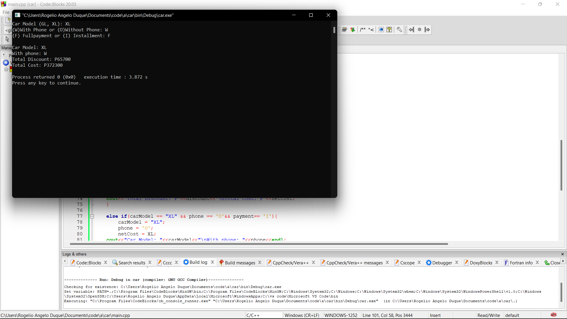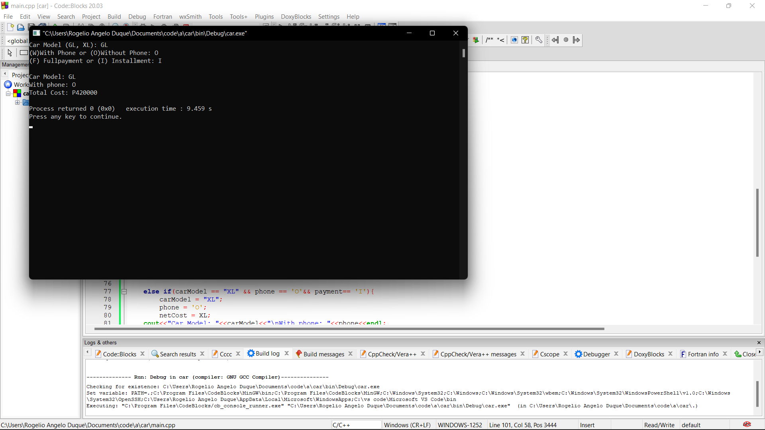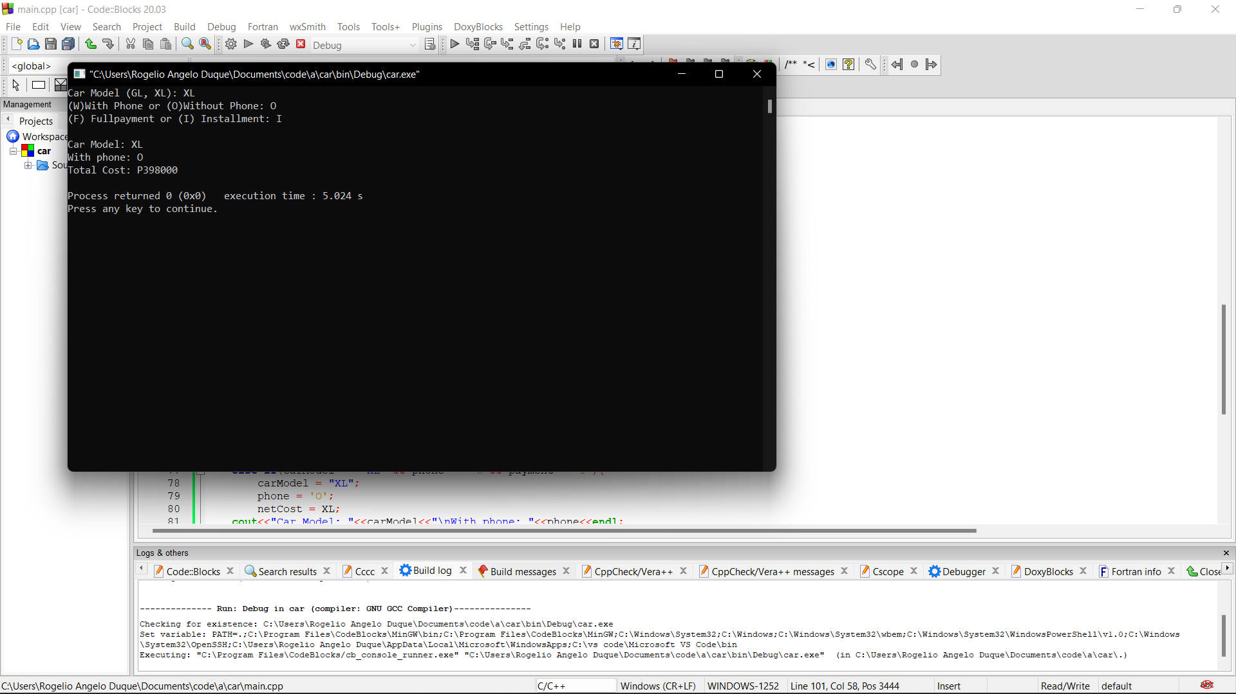

1. Store of Asia sells the following:

Fruit Code Fruit Name Local Imported

G GUAVA P4.50 per piece P25.50 per piece

A AVOCADO P75.50 per dozen P250.00 per dozen

P POMELO P75.00 per half dozen P100.00 per half dozen

M MANGO P50.00 per piece P60.00 per piece

Y PAPAYA P23.00 per piece P25.00 per piece

Write a program that would input fruit code bought by the customer, its type code ("I" for imported and "L" for local), and the quantity.  Program must then output the customer's total bill.

#include <iostream>

using namespace std;

int main()

{

    char fruitCode, type;

    double quantity, bill;

    cout<<"Fruit Code  Fruit Name     Local                        Imported"<<endl;

    cout<<"G           Guava          P4.50 per piece           P25.50 per piece"<<endl;

    cout<<"A           AVOCADO        P75.50 per dozen          P250.00 per dozen"<<endl;

    cout<<"P           POMELO         P75.00 per half dozen        P100.00 per half dozen"<<endl;

    cout<<"M           MANGO          P50.00 per piece          P60.00 per piece"<<endl;

    cout<<"Y           PAPAYA         P23.00 per piece          P25.00 per piece"<<endl;

cout<<"\n";

    cout<<"Fruit You Wan To Buy (Fruit Code): ";

    cin>>fruitCode;

    cout<<"Piece or dozen you want to buy: ";

    cin>>quantity;

    cout<<"(I)Imported or (L)Local: ";

    cin>>type;

    if(fruitCode == 'G' && type == 'L'){

        bill = quantity * 4.50;

        cout<<"Total Bill: P"<<bill;

    }

    else if(fruitCode == 'G' && type == 'I'){

        bill = quantity * 25.50;

        cout<<"Total Bill: P"<<bill;

    }

    else if(fruitCode == 'A' && type == 'L'){

        bill = quantity * 75.50;

        cout<<"Total Bill:P"<<bill;

    }

    else if(fruitCode == 'A' && type == 'I'){

        bill = quantity * 250.50;

        cout<<"Total Bill: P"<<bill;

    }

    else if(fruitCode == 'P' && type == 'L'){

        bill = quantity * 75.50;

        cout<<"Total Bill: P"<<bill;

    }

    else if(fruitCode == 'P' && type == 'I'){

        bill = quantity * 100.50;

        cout<<"Total Bill: P"<<bill;

    }

    else if(fruitCode == 'M' && type == 'L'){

        bill = quantity * 50;

        cout<<"Total Bill: P"<<bill;

    }

    else if(fruitCode == 'M' && type == 'I'){

        bill = quantity * 60;

        cout<<"Total Bill: P"<<bill;

    }

    else if(fruitCode == 'Y' && type == 'L'){

        bill = quantity * 23;

        cout<<"Total Bill: P"<<bill;

    }

    else if(fruitCode == 'Y' && type == 'I'){

        bill = quantity * 25;

        cout<<"Total Bill: P"<<bill;

    }

    return 0;

}

